Project Title
Transportation Management System (TMS)

Motivation
The logistics and transportation industry faces challenges like inefficient routing, delayed shipments, and poor visibility. The motivation behind developing the Smart Transportation Management System is to streamline the entire transportation process, improve tracking and routing, and provide real-time updates to all stakeholders. This system aims to reduce costs, enhance customer satisfaction, and minimize delays by leveraging modern web technologies and data integration.

Benefits / Contribution
- Improved Visibility: Real-time tracking of shipments using integrated map APIs, providing live status updates.
- Enhanced Efficiency: Automated route optimization to minimize delivery time and fuel consumption.
- User-Friendly Interface: A responsive dashboard for users to view, track, and manage shipments easily.
- Centralized Data Management: Seamless management of shipments, drivers, and vehicles through a centralized database.
- Scalable Solution: The system can accommodate future expansions in fleet size and additional services.

Database
- Database Management System: MySQL (managed using XAMPP)
Key Tables:
- users: Manages all user data, including administrators, drivers, and clients.
  - Stores user credentials, contact information, and roles.
- vehicles: Contains details about the fleet of vehicles.
  - Includes vehicle number, type, capacity, and current status (available, in transit, maintenance).
- drivers: Holds information about drivers.
  - Includes name, license number, phone number, and assigned vehicle.
- shipments: Tracks all shipments and their statuses.
  - Stores information such as user, driver, vehicle, source, destination, and current status (pending, in transit, delivered).
- locations: Keeps a log of location updates for real-time tracking of shipments.
  - Stores latitude, longitude, and timestamp linked to a specific shipment.
- schedule: Manages the scheduling of vehicles and drivers.
  - Stores the vehicle, assigned driver, start and end time, and associated route.
- routes: Defines the paths taken for deliveries.
  - Includes start and end locations, estimated duration, and distance.
- booking: Manages user bookings for shipment services.
  - Tracks booking details including user, shipment, booking date, and status (confirmed, canceled, completed).
Data Flow Diagram (DFD)
DFD level 0:
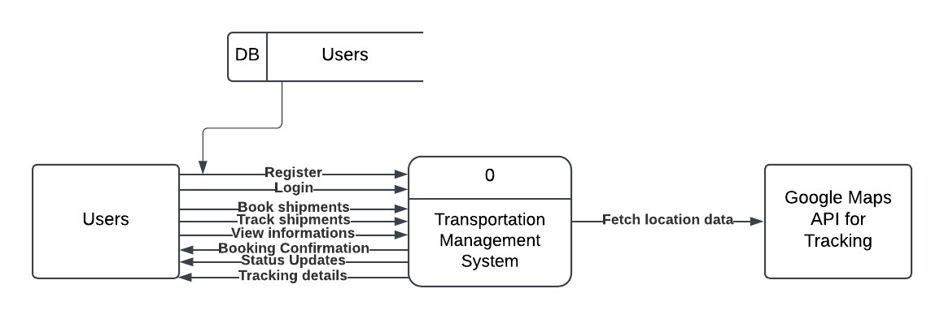

DFD level 1:

Language and Environment
- Frontend: HTML, CSS, JavaScript (React for UI)
- Backend: Node.js with Express
- Database: MySQL (XAMPP)
- Development Environment: VS Code
- API Integration: Google Maps API for location tracking, mock API for testing shipment data

